|  | |
| --- | --- |
|  | CB Orders |
| Project Vision Document | |
| **Version 1.0** | |
| October 2, 2022 | |

**Revision History**

| Revision | Date | Author | Reviewed By | Summary of Changes |
| --- | --- | --- | --- | --- |
| Initial Draft | September 28, 2022 | Kym Michael Gripal | Mustafa Izci | Added content and current workflow diagram |
| Edit | September 30, 2022 | Kym Michael Gripal | Omar Nabi | Added content |
| Final Revision | October 2, 2022 | Kym Michael Gripal | Reyansh Srivastava, Arshpreet Kaur | Grammar checks |

**Document Approval List**

| Version | Approved By | Signature | Date |
| --- | --- | --- | --- |
| 1.0 | Kym Michael Gripal |  | October 2, 2022 |
| 1.0 | Mustafa Izci |  | October 2, 2022 |
| 1.0 | Omar Nabi |  | October 2, 2022 |
| 1.0 | Reyansh Srivastava |  | October 2, 2022 |
| 1.0 | Arshpreet Kaur |  | October 2, 2022 |

**Document Distribution List**

| Version | Name of the Receiver/Group | Date |
| --- | --- | --- |
| 1.0 | Anjana Shah | October 2, 2022 |
|  |  |  |
|  |  |  |

**Table of Contents**

1 Introduction 4

1.1 Purpose 4

1.2 Scope 4

1.2.1 In Scope 4

1.2.2 Out of Scope 4

1.3 Definitions, Acronyms, and Abbreviations 4

1.4 References 4

2 Project Vision Statement 4

3 Positioning 5

3.1 Business Opportunity 5

3.2 Problem Statement 5

3.3 Product Position Statement 6

4 Stakeholder and User Descriptions 6

4.1 Stakeholder Summary 6

4.2 User Summary 7

5 Stakeholder Requirements 8

6 System Features 9

7 Assumptions 9

8 Constraints 10

# Introduction

This project contains an overview of the project. It contains information about what the purpose of the project is, why we chose this project, opportunities, and future expectations.

## Purpose

The purpose of this document is to collect and describe the overall details and scope for Good App’s CB Orders application. This includes the problems and opportunities shown by creating the application, the user’s requirements, and an overview of the application’s features.

## Scope

### In Scope

CB Orders is a web-based application that automates the procurement process for CB. This will include a clean e-commerce interface for the clients, a kanban-style graphical user interface (UI) for the workers, a robust database storing all inventory information of the departments and the ability to generate invoices for the clients.

### Out of Scope

This application will be exclusively for the use of CB warehouse, accounting and concierge departments and will not be extended to regular clients of CB’s other departments. Also, it will also not be open sourced for the foreseeable future.

## Definitions, Acronyms, and Abbreviations

Kanban - An agile project management tool designed to help visualize work, limit work-in-progress, and maximize efficiency

eCommerce - is the buying and selling of goods and services, or the transmitting of funds or data, over an electronic network, primarily the internet

## References

| Reference File Name | Version | Description |
| --- | --- | --- |
| Template for Creating a Project Vision Statement | 1.0 | <http://wiki.doing-projects.org/index.php/Project_Vision_Statement> |
| Project Vision Statement -Make Sure It Works | 1.0 | <https://teamhood.com/project-management/project-vision-statement-make-sure-it-works/> |

# Positioning

## Business Opportunity

CB is a delicatessen which specializes in cheese and deli meats. It is an institution that has served the Greater Toronto Area for over five decades and has been the premier destination for foodies and chefs alike. As such, streamlining operations are of utmost importance for the longevity of the business. This web application achieves this goal by leveraging current web technologies to automate and streamlining order management and invoice generation for CB’s warehouse, concierge, and accounting departments.

## Problem Statement

CB’s warehouse department is serving over 150 restaurants and clients all over the Greater Toronto Area. Every week, the department receives and ships out over 200 orders, with as much as 300 orders at peak dates. As such, streamlining production is a key priority to the department while maintaining high standards.

Currently, the department does most of its transactions using emails, whether it’s an order directly placed by a client, working orders generated by Rekki (an ordering platform for restauranteurs to procure produce from distributors), or sending finished order copies to the accounting department for invoicing.

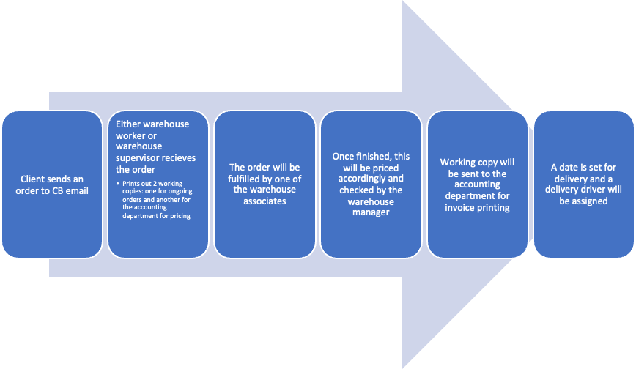

**Figure 1 Current Workflow of CB Warehouse Department**

| The Problem of | the use of emails in processing orders |
| --- | --- |
| affects | overall productivity and output |
| the impact of which is | disorganization of orders |
| a successful solution would be | a web-based ordering system |

**Table 1 Problem Statement**

## Product Position Statement

| For | CB Warehouse, concierge, and accounting departments |
| --- | --- |
| Who | needs a streamlined order management |
| CB Orders | is an ordering system |
| That | provides tools to streamline order management |
| Unlike | emails or services such as Rekki |
| Our product | is more flexible to cater the business needs as they see fit and has lower operating costs |

**Table 2 Product Position Statement**

# Stakeholder and User Descriptions

## Stakeholder Summary

| Stakeholder Name | Represents | Role |
| --- | --- | --- |
| Full stack Engineer | This stakeholder is chiefly in charge of the system's development. | Responsible for designing and developing websites and platforms, also providing back-end functionality that can run smoothly from any device or browser type commonly used today. |
| DevOps Engineer | The application will be created by the engineer. The engineer will also deal with system bugs and related issues. | To work with developers and the IT staff to oversee the code releases, combining an understanding of both engineering and coding. To implement systems software to analyze data to improve existing ones, they increase productivity in the workplace. |
| Product Manager | A stakeholder who collaborates with other stakeholders to identify their needs is this one. | Defining a vision for a product.  Aligning stakeholders around the vision for the product.  Prioritizing product features and capabilities. Creating a shared brain across larger teams to empower independent decision-making. |

**Table 3 Stakeholder Summary**

## User Summary

| Username | Description | Responsibilities | Stakeholder |
| --- | --- | --- | --- |
| Shop Owner | The system's principal end user. | See what employees have been entering, editing, and deleting on the system. Manage profiles and download reports. | Self |
| Warehouse Supervisor | The system's end user | Manages the inventories and orders new stock if it’s not available in the inventories. | Self |
| Client | The system's end user | Takes care of the business by taking the orders and implementing the orders when needed. | Self |

**Table 4 User Summary**

# Stakeholder Requirements

| **ID** | **Requirement** | **Stakeholder** |
| --- | --- | --- |
| 1 | Handle DNS request | Full stack Engineer |
| 2 | Handle HTTP request | Full stack Engineer |
| 3 | Start Application | Full stack Engineer |
| 4 | Accept keyboard input | Full stack Engineer |
| 5 | Exit application | Full stack Engineer |

# System Features

| **ID** | **Feature** | **Stakeholder Requirement ID** |
| --- | --- | --- |
| 1 | Create account | 1,2,4 |
| 2 | Delete account | 1,2 |
| 3 | Search function | 1,2 |
| 4 | Manual order management | 1,2,4 |
| 5 | Inventory Management | 1,2,4 |
| 6 | Filter function | 1,2,4 |
| 7 | Invoice generation | 1,2 |
| 8 | eCommerce Area | 1,2,4 |
| 9 | Chat function | 1,2,4 |

# Assumptions

This project assumes the following:

* The warehouse, concierge, and the accounting departments have access to computers and internet
* The stakeholders will have a separate budget for deployment and maintenance of the web application
* The web application should have the capability to be flexible to cater the stakeholder’s needs

# Constraints

The project’s constraints are the following:

* This will not disrupt any current workflows being implemented by CB and will be isolated from the current avenues of contact used by the departments
* This will not keep any identifiable and financial information about the clients indefinitely
* This version will not enforce the use of payment processing options.